How to find Fortiagte-VM AMI

Marketplace > Subscribe to image

<https://aws.amazon.com/marketplace/pp/B00ISG1GUG?ref_=aws-mp-console-subscription-detail-byol#pdp-pricing>

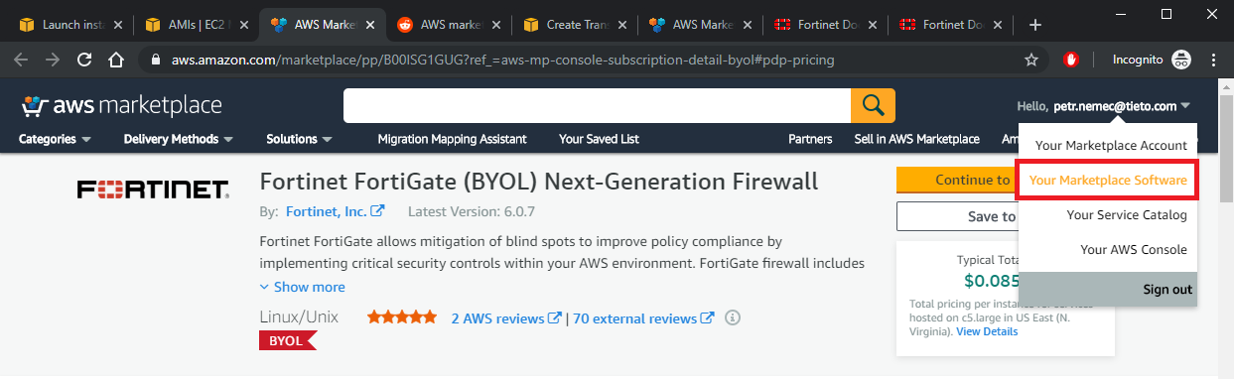

Marketplace > Your Marketplace Software

ami-01ccce1a224948c6f

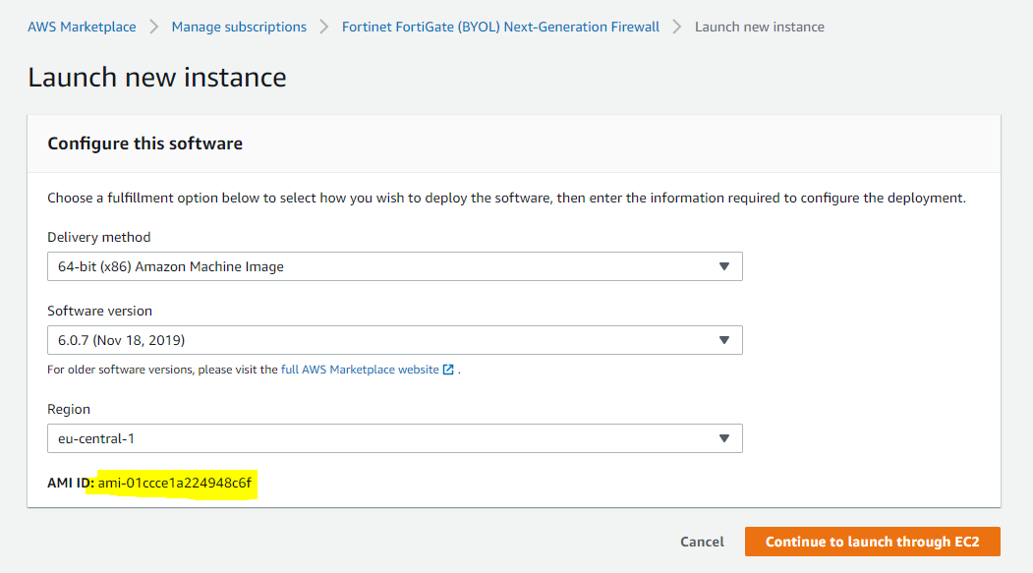

Or EC2 > Images > AMI

